30 mins

BAKE

18 to 23 mins

TOTAL

1 hr 20 mins

YIELD

12 scones

[SAVE RECIPE](https://www.kingarthurbaking.com/recipebox)

PRINT

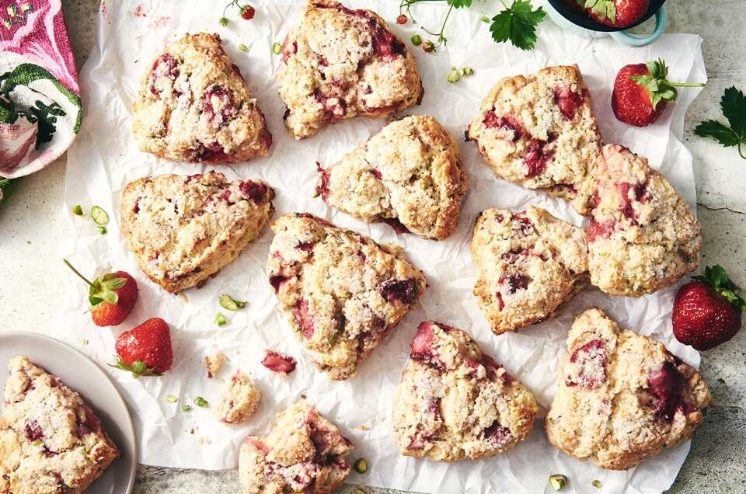

Ingredients [Shop this Recipe](https://shop.kingarthurbaking.com/items/unbleached-all-purpose-flour)

Berries

* 2 cups (334g) strawberries, sliced or quartered
* 1 tablespoon granulated sugar

Dough

* 2 3/4 cups (330g) [King Arthur Unbleached All-Purpose Flour](https://shop.kingarthurbaking.com/items/unbleached-all-purpose-flour)
* 1/3 cup (67g) granulated sugar
* 3/4 teaspoon salt
* 1 tablespoon baking powder
* 8 tablespoons (113g) unsalted butter, cold, cut in 1/2" dice
* 1/2 cup (60g) pistachios, chopped
* 2 large eggs
* 2 teaspoons [King Arthur Pure Vanilla Extract](https://shop.kingarthurbaking.com/items/king-arthur-pure-vanilla-extract)
* 1/2 cup (113g) half-and-half

Topping

* 2 teaspoons milk or half-and-half
* 2 tablespoons [coarse sparkling sugar](https://shop.kingarthurbaking.com/items/sparkling-sugar), optional

#### Instructions

* Preheat the oven to 425°F. Line a baking sheet with parchment.
* To roast the berries: In a medium bowl, combine the strawberries with the sugar, tossing them gently to coat.
* Spread the berries evenly on the baking sheet and roast for about 20 minutes, or until they've softened and look "jammy." Remove the baking sheet from the oven and place it on a rack; let the berries cool while you prepare the dough.
* To make the dough: In a large mixing bowl, whisk together the flour, sugar, salt, and baking powder.  
  Learn more
* 
* BLOG

##### [Grilling and roasting fruit for baking](https://www.kingarthurbaking.com/blog/2018/06/20/grilling-and-roasting-fruit-for-baking)

* BY ANNABELLE NICHOLSON
* Work in the butter just until the mixture is unevenly crumbly; it's OK for some larger chunks of butter to remain unincorporated.
* Stir in the chopped nuts and roasted fruit, including any juice that collected on the baking sheet during roasting.
* In a separate bowl, whisk together the eggs, vanilla, and half-and-half. Add the liquid ingredients to the dry ingredients.
* Using a [bowl scraper](https://shop.kingarthurbaking.com/items/king-arthur-bowl-scraper) or a large spoon, stir until everything is moistened and holds together. If the mixture seems dry, drizzle in additional half-and-half about a teaspoon at a time until the dough comes together.
* Scrape any remaining bits of roasted berries from the parchment, and use it to re-line the baking sheet. Sprinkle a bit of flour atop the parchment.
* To shape the scones: Using a [bowl scraper](https://shop.kingarthurbaking.com/items/king-arthur-bowl-scraper) or your hands, transfer the dough to the floured parchment. Divide it in half. Shape each half into a rough 6" circle about 3/4" thick.
* Using a knife or [bench knife](https://shop.kingarthurbaking.com/items/bench-knife) run under cold water, slice each circle into six wedges.
* Brush the wedges with milk, and sprinkle with sparkling sugar.
* Carefully pull the wedges away from the center to separate them just a bit; there should be about 1/2" space between them at their outer edges.
* For best texture and highest rise, place the pan of scones in the freezer for 30 minutes, uncovered. Chilling the scones relaxes the gluten in the flour, which makes the scones more tender and allows them to rise higher. It also chills the fat, which will make the scones a bit flakier.
* While the scones are chilling, preheat the oven to 425°F with a rack in the upper third.
* To bake the scones: Bake the scones for 18 to 23 minutes, or until they're a light golden brown. When you pull one away from the others it should look baked all the way through; the interior shouldn't look wet or unbaked.
* Remove the scones from the oven and cool briefly on the pan; serve warm. They're delicious as is, but add butter and/or jam, if you like.
* Storage information: Wrap any leftover scones (completely cooled) and store at room temperature for up to several days. To reheat, place on a baking sheet, tent lightly with foil, and warm in a preheated 350°F oven for about 10 minutes.

#### Tips from our Bakers

* Step up your scone baking game by checking out the tips and techniques in our [Scone Baking Guide](https://www.kingarthurbaking.com/learn/guides/scone). It has everything you need to know — from details on shaping to add-ins to glazes and more — to make scones like a pro.